## Convert Below Named functions to first class and anonymous functions

function sayHello() {

console.log(“Hello”);

}

//named fun

function sayHello() {

    console.log("Hello");

}

sayHello()

//first class fun

var printer=function sayHello() {

    console.log("Hello");

}

printer()

//Anonymous fun

var printer=function () {

    console.log("Hello");

}

printer()

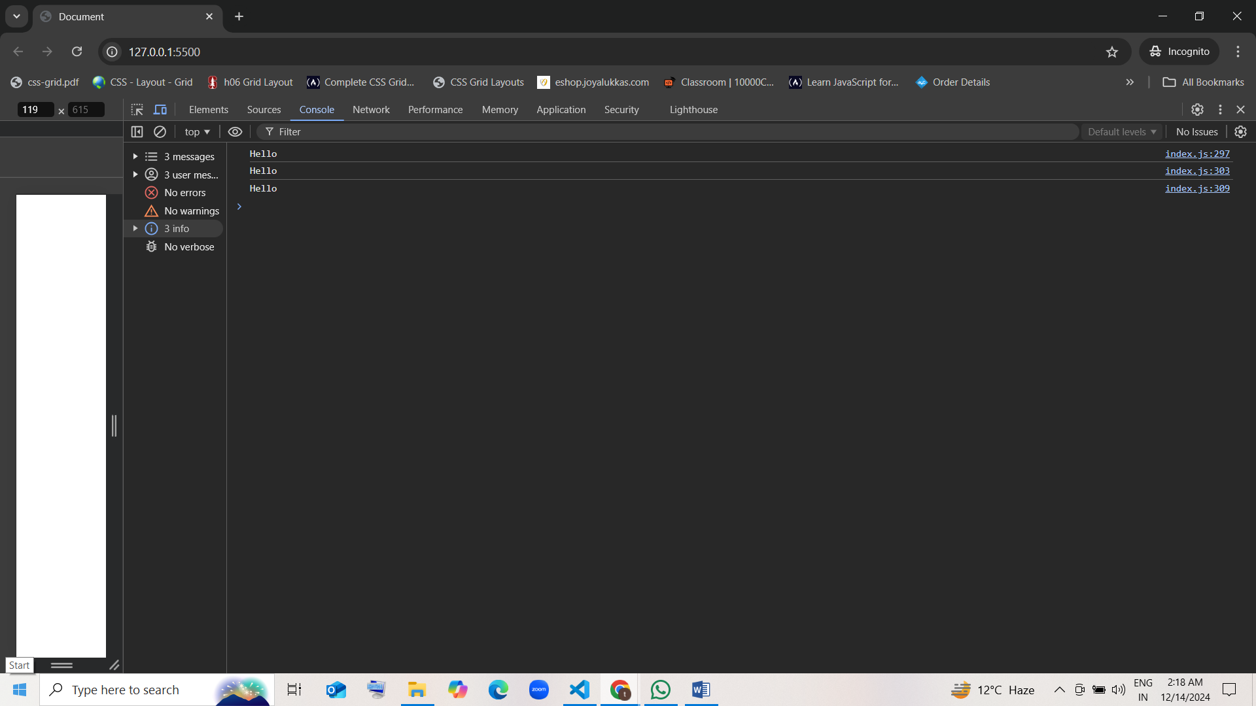

===================================================================

function printNumber() {

console.log(5);

}

// named fun

function printNumber() {

    console.log(5);

}

printNumber()

// first class fun

var demo=function printNumber() {

    console.log(5);

}

demo()

// Anonymous fun

var demo=function () {

    console.log(5);

}

demo()

====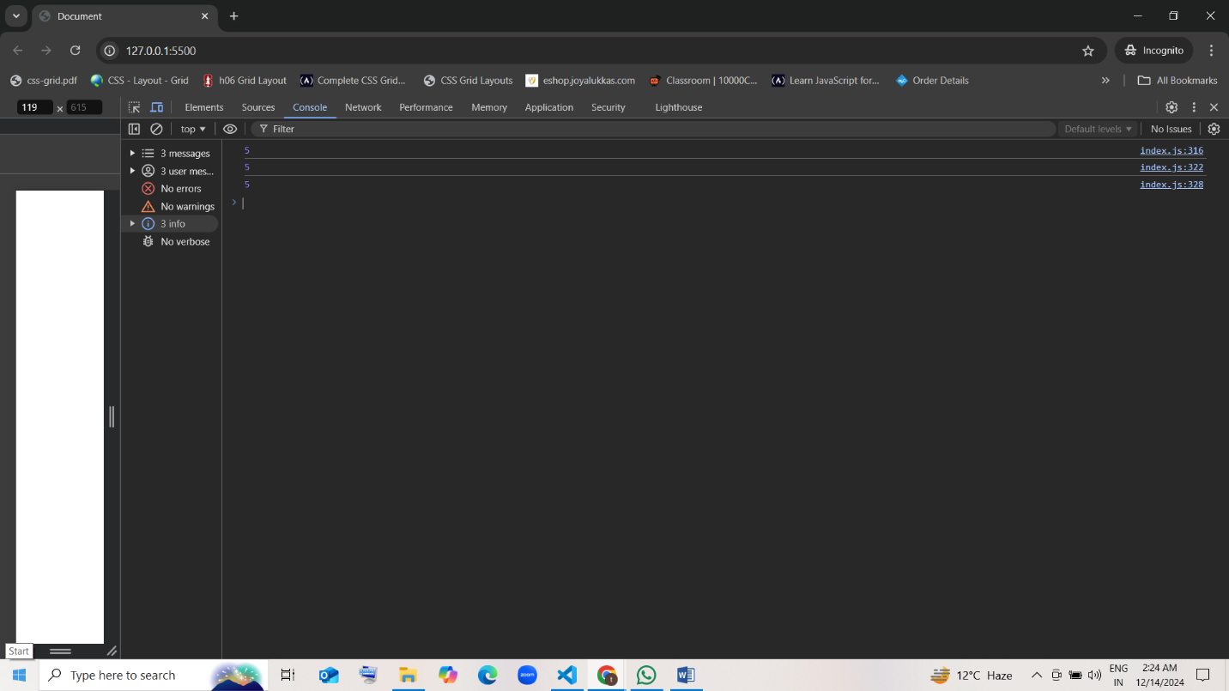================================

function addAndPrint() {

console.log(2 + 3);

}

// named fun

function addAndPrint() {

    console.log(2 + 3);

}

addAndPrint()

//first class fun

var print=function addAndPrint() {

    console.log(2 + 3);

}

print()

// Anonymous fun

var print=function () {

        console.log(2 + 3);

}

print()

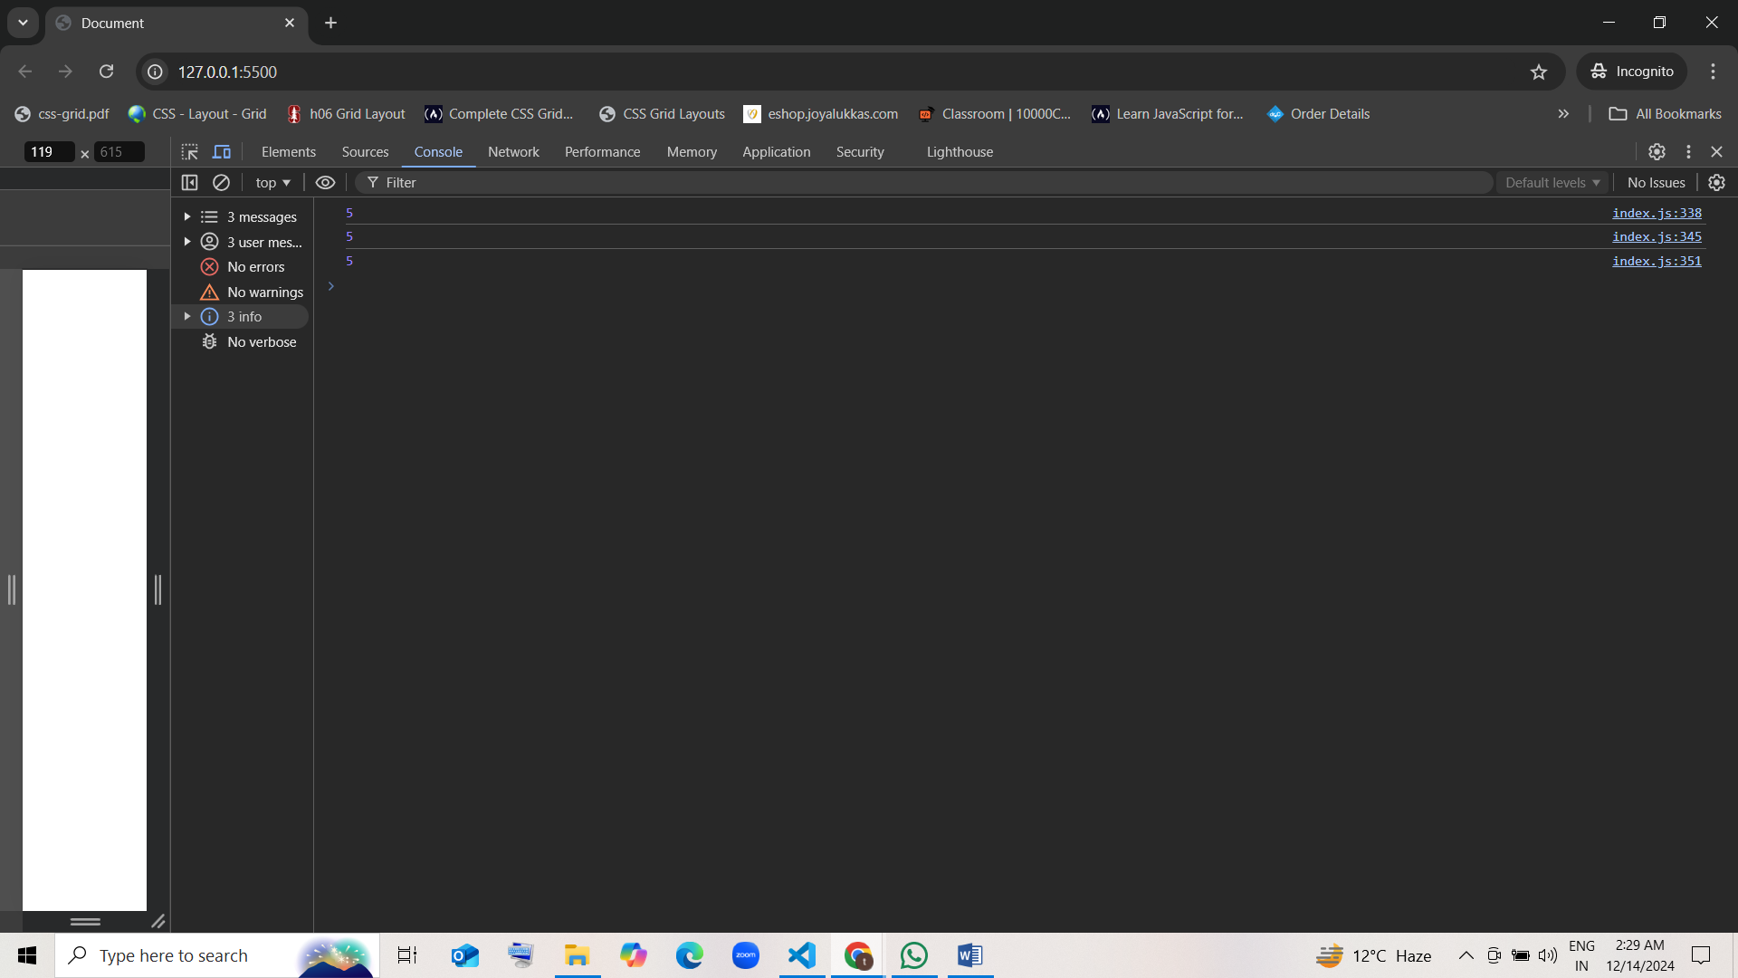

====================================

function add(a, b) {

return a + b;

}

// named

function add(a, b) {

    return a + b;

}

console.log(add(15,30))

// first class fun

var demo1=function add(a, b) {

    return a + b;

}

console.log(demo1(15,30))

// Anonymous fun

var demo1=function (a, b) {

    return a + b;

}

console.log(demo1(15,30))

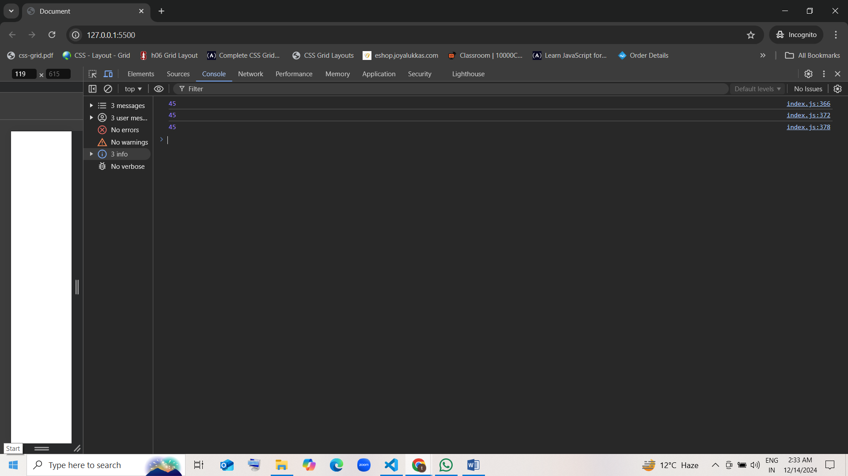

====================================

function subtract(a, b) {

return a - b;

}

// named fun

function subtract(a, b) {

    return a - b;

}

console.log(subtract(14, 7))

// first class fun

var result=function subtract(a, b) {

    return a - b;

}

console.log(result(14, 7))

// Anonymous fun

var result=function (a, b) {

    return a - b;

}

console.log(result(14, 7))

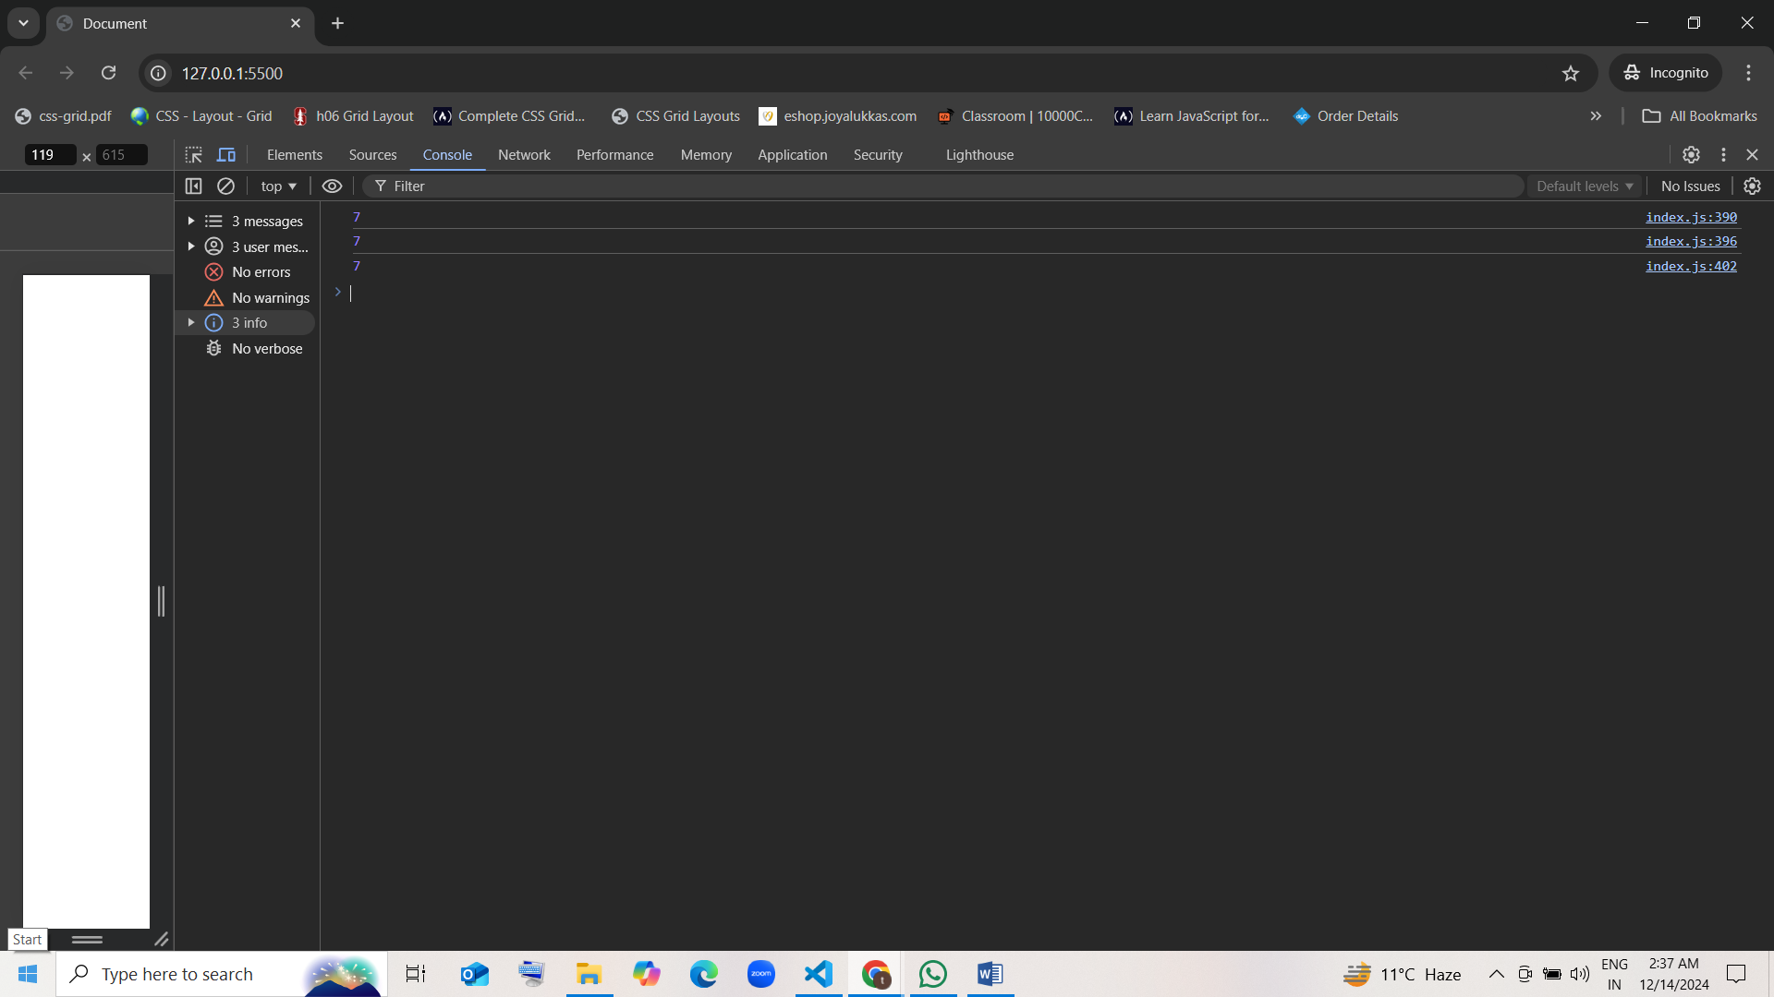

=====================================

function double(x) {

return x + x;

}

// named fun

function double(x) {

    return x + x;

}

console.log(double(10))

// first class fun

var demo2=function double(x) {

    return x + x;

}

console.log(demo2(10))

// Anonymous fun

var demo2=function (x) {

    return x + x;

}

console.log(demo2(10))

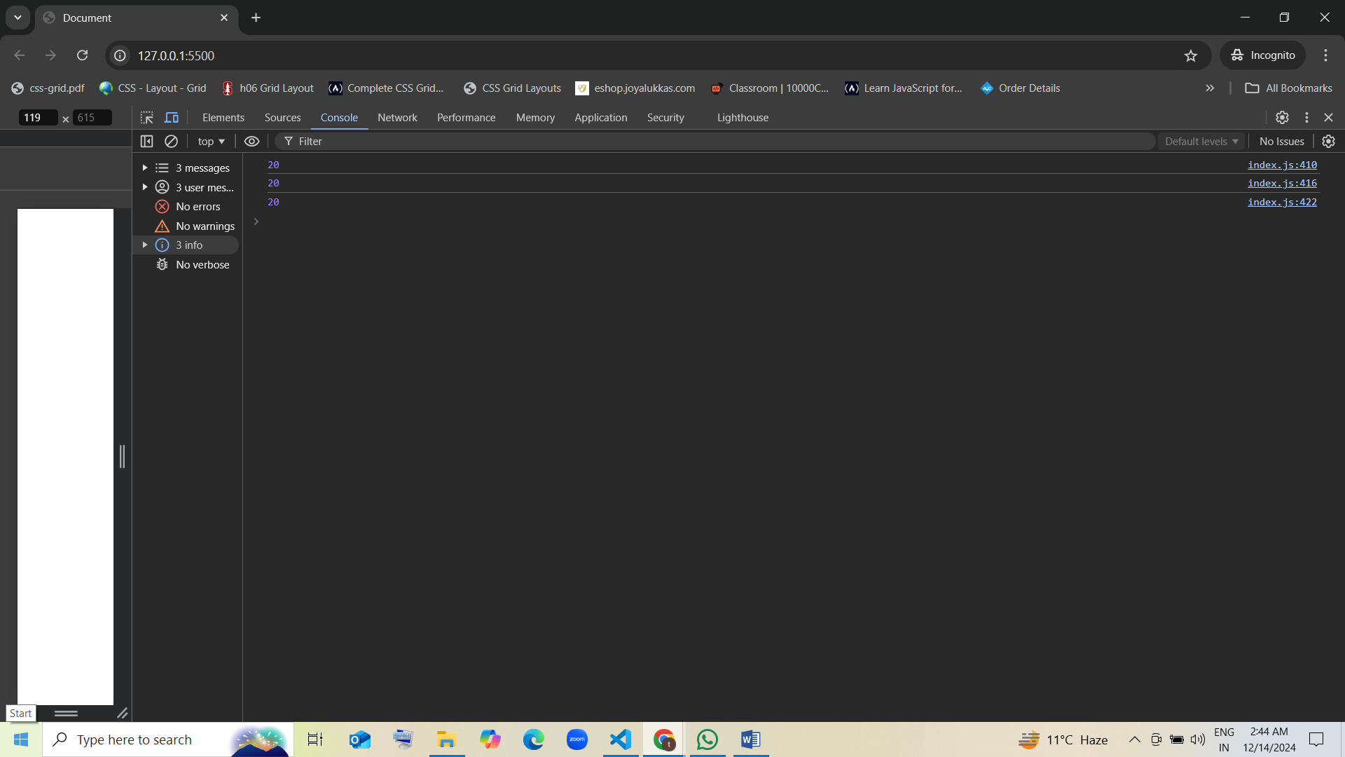

=====================================

function square(x) {

return x * x;

}

// named fun

function square(x) {

    return x * x;

}

console.log(square(5))

// first class fun

var multiply=function square(x) {

    return x * x;

}

console.log(multiply(5))

// Anonymous fun

var multiply=function (x) {

    return x * x;

}

console.log(multiply(5))

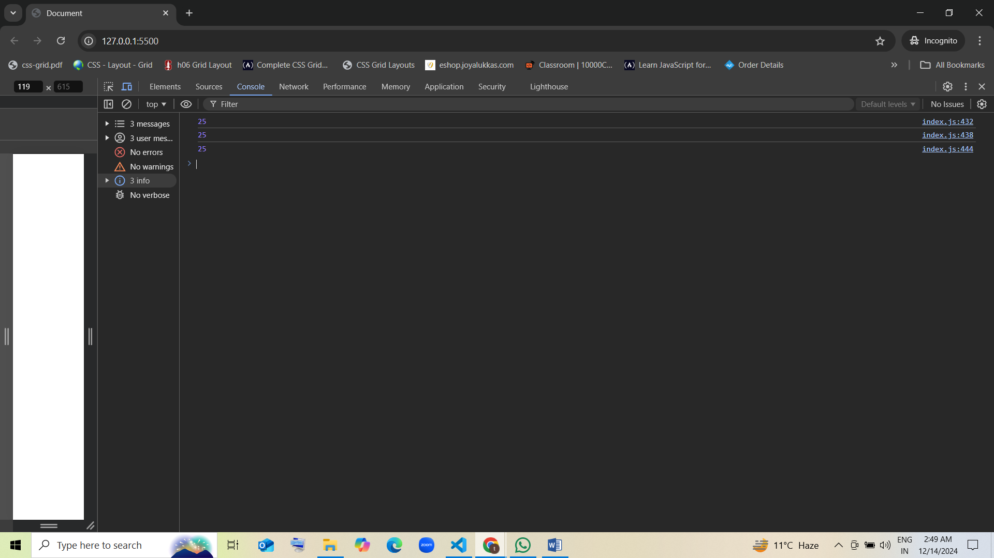

=====================================

function isPositive(x) {

return x > 0;

}

// named fun

function isPositive(x) {

    return x > 0;

}

console.log(isPositive(3))

// first class fun

var operator=function isPositive(x) {

    return x > 0;

}

console.log(operator(3))

// Anonymous fun

var operator=function (x) {

    return x > 0;

}

console.log(operator(3))

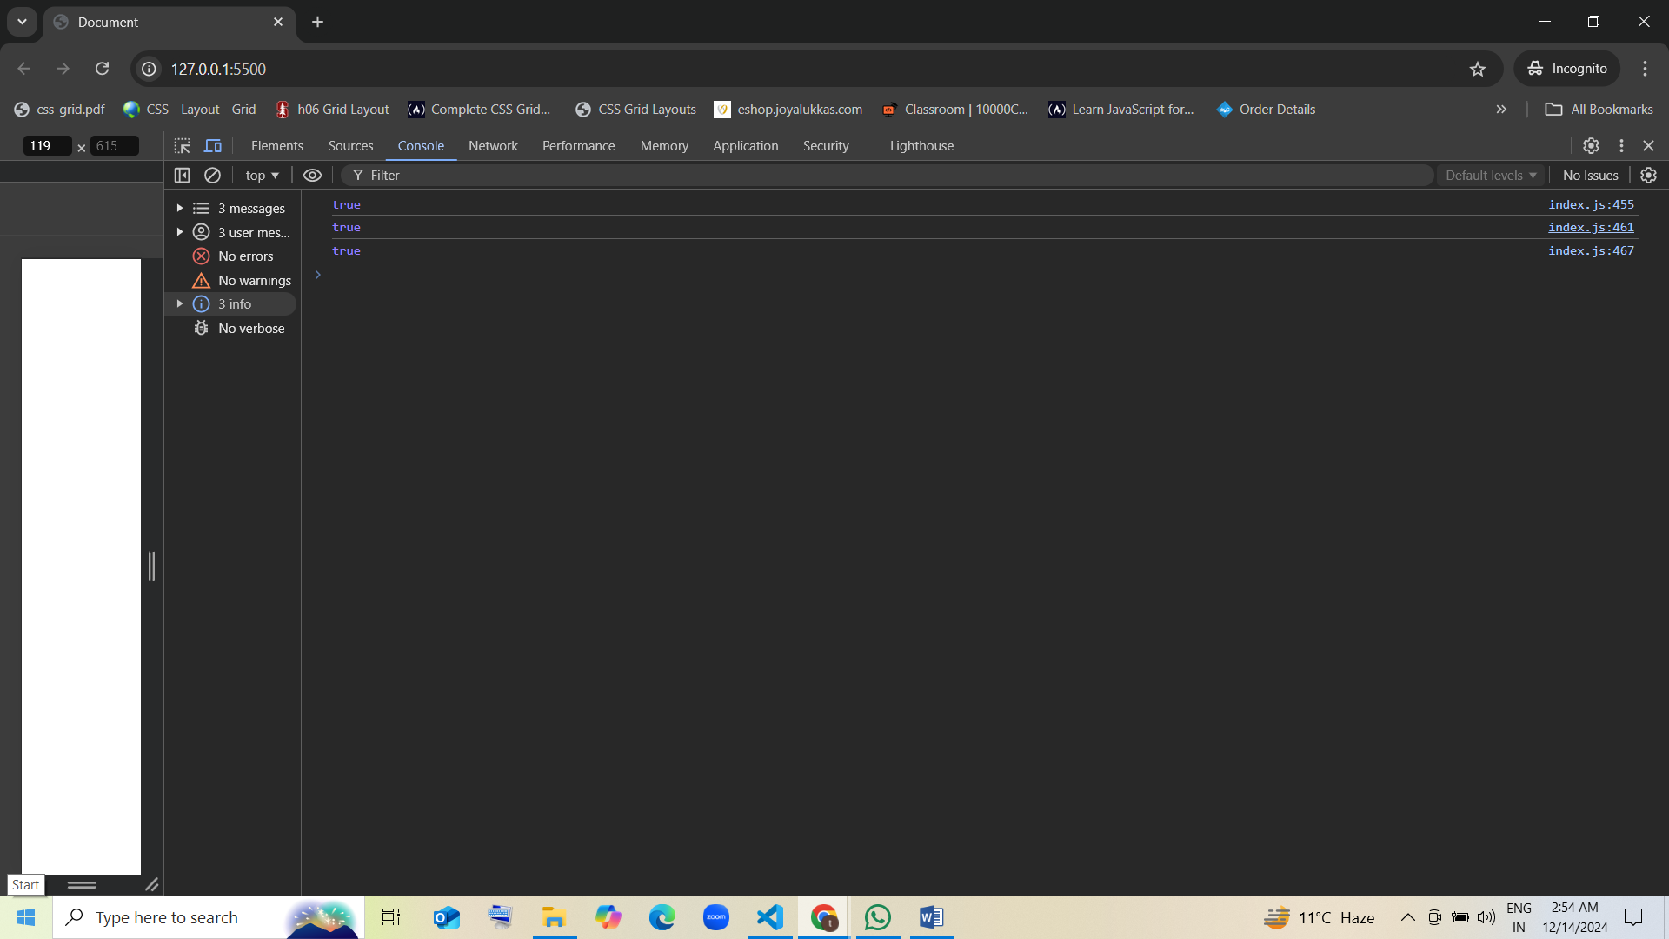

=====================================

function absolute(x) {

if (x < 0) {

return 0 - x;

}

return x;

}

// named fun

function absolute(x) {

    if (x < 0) {

    return 0 - x;

    }

     return x;

}

console.log(absolute(20))

// first class fun

var statement=function absolute(x) {

    if (x < 0) {

    return 0 - x;

    }

     return x;

}

console.log(statement(20))

// Anonymous fun

var statement=function (x) {

    if (x < 0) {

    return 0 - x;

    }

     return x;

}

console.log(statement(20))

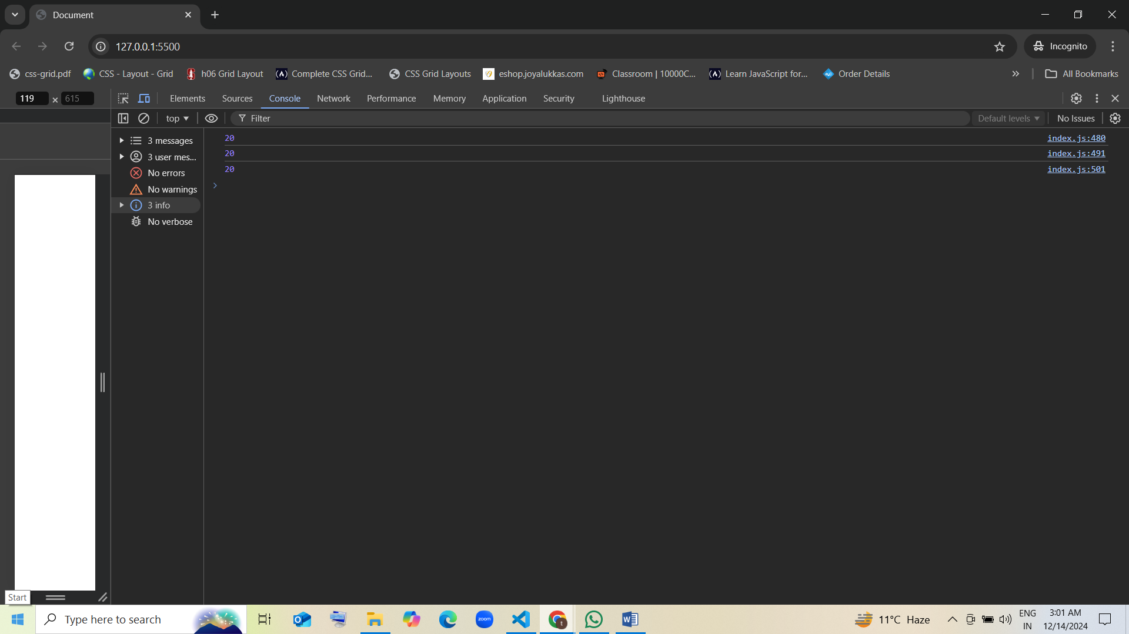

// named fun

function absolute(x) {

    if (x < 0) {

    return 0 - x;

    }

     return x;

}

console.log(absolute(-5))

// first class fun

var statement=function absolute(x) {

    if (x < 0) {

    return 0 - x;

    }

     return x;

}

console.log(statement(-5))

// Anonymous fun

var statement=function (x) {

    if (x < 0) {

    return 0 - x;

    }

     return x;

}

console.log(statement(-5))

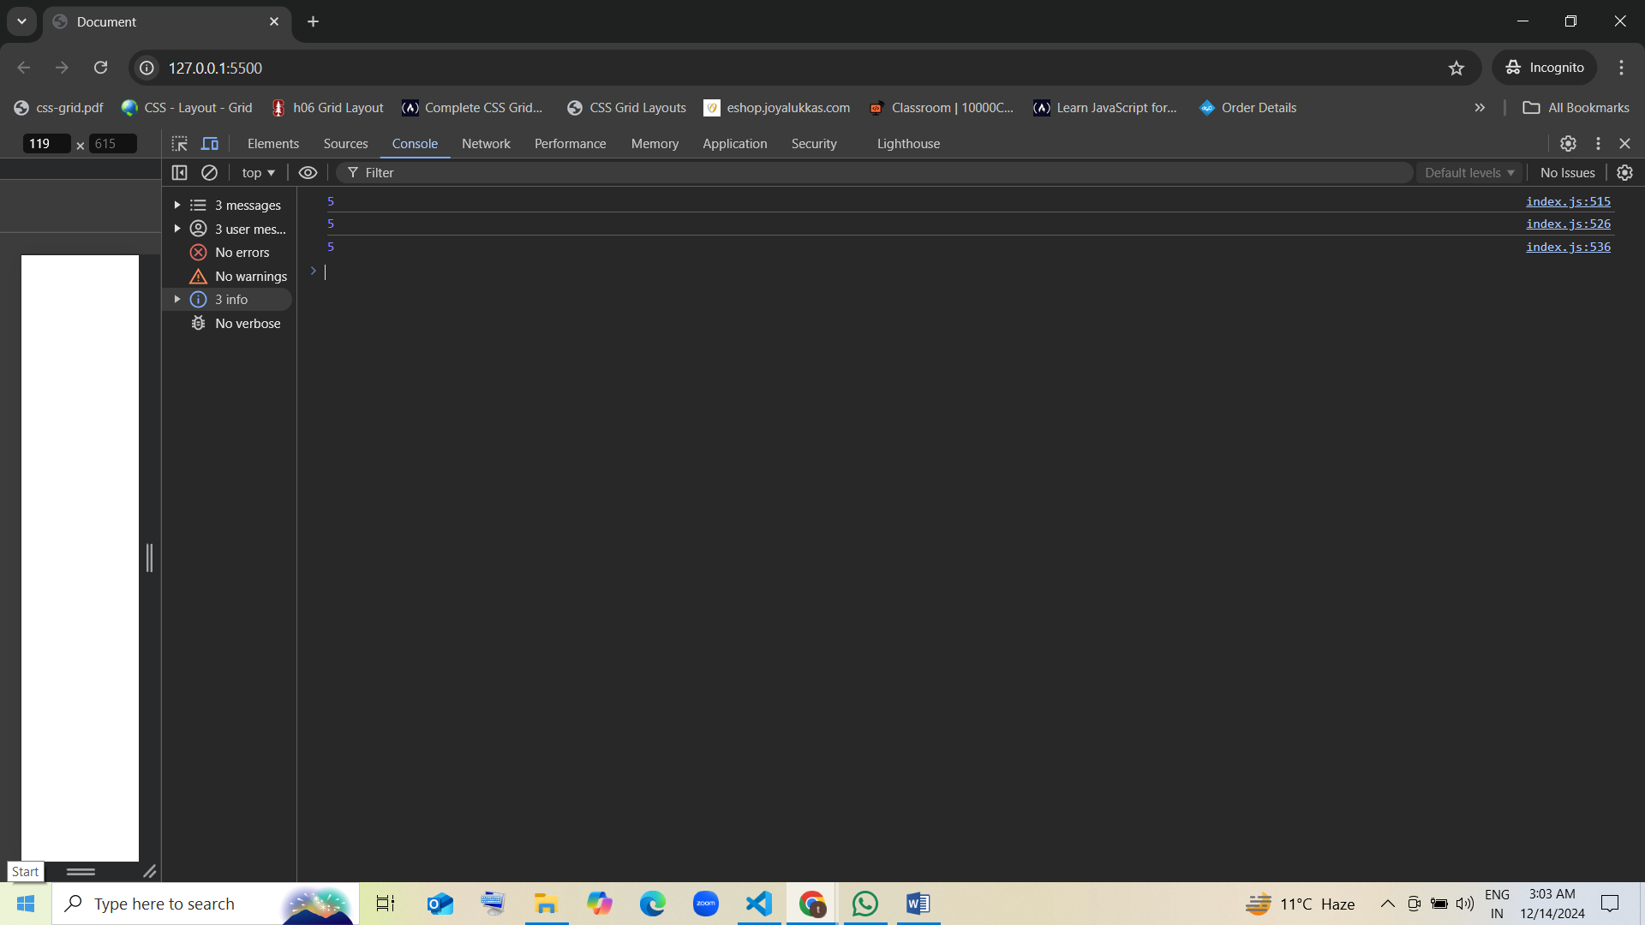

=====================================

function max(a, b) {

if (a > b) {

return a;

}

return b;

}

// named fun

function max(a, b) {

    if (a > b) {

    return a;

    }

    return b;

}

console.log(max(18,14))

// first class fun

var greater=function max(a, b) {

    if (a > b) {

    return a;

    }

    return b;

}

console.log(greater(18,14))

// Anonymous fun

var greater=function (a, b) {

    if (a > b) {

    return a;

    }

    return b;

}

console.log(greater(18,14))

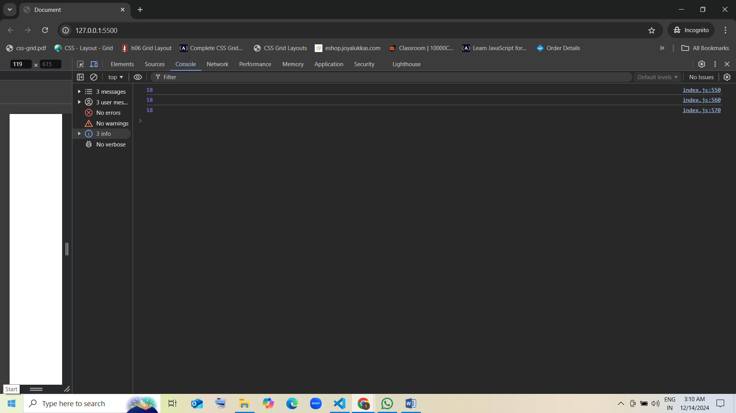

// named fun

function max(a, b) {

    if (a > b) {

    return a;

    }

    return b;

}

console.log(max(12,14))

// first class fun

var greater=function max(a, b) {

    if (a > b) {

    return a;

    }

    return b;

}

console.log(greater(12,14))

// Anonymous fun

var greater=function (a, b) {

    if (a > b) {

    return a;

    }

    return b;

}

console.log(greater(12,14))

